

TOWN OF MORRIS

MINUTES OF THE

REGULAR MEETING OF COUNCIL

Held November 2, 2018 @ 7:01 pm

Councillors Present: Tim Lewis

Trevor Thiessen

Chris Hamblin

Ruth Murray

Margaret Johnston

Mel Baxter

Also Present: Brigitte Doerksen, CAO

Chris Janke, CFO

Presiding: Mayor Scott Crick

**01/11/18** **Moved by Councillor Ruth Murray**

Agenda **Seconded by Councillor Maragret**

**BE IT RESOLVED** that the Agenda for the November 1st, 2018 regular Council meeting be approved as presented

**(Carried)**

**02/11/18** **Moved by Councillor Tim Lewis**

Minutes **Seconded by Councillor Trevor Thiessen**

**BE IT RESOLVED that** the minutes for the September 27, 2018 Regular Council meeting be adopted as presented.

**(Carried)**

**03/11/18 Moved by Councillor Chris Hamblin**

Excused **Seconded by Councillor Mel Baxter**

Council Mbrs **BE IT RESOLVED** that Council accept the following Members from Council for November 1st, 2018 Regular Council Meeting as;

In attendance: Mayor Scott Crick, Deputy Mayor Chris Hamblin, Councillors Tim Lewis, Margaret Johnston, Trevor Thiessen, Mel Baxter, Ruth Murray

Excused: none

Unexcused: none

**(Carried)**

**DELEGATIONS:** None

**CORRESPONDENCE:**

1. Email Request-Court Service in Town Noted & discussed
2. Letter of Thanks- Valley Regional Library Noted & discussed

**SEMINARS & EDUCATION:**

1. Pembina Valley Water COOP #04/11/18
2. Red River Basin Commission Gala #05/11/18
3. Chamber of Commerce-Cyber Security Session #06/11/18
4. Dekalb Mayor Invite #07/11/18

**04/11/18 Moved by Councillor Margaret Johnston**

Pembina V **Seconded by Councillor Ruth Murray**

Water COOP **NOW THERFORE BE IT RESOLVED** that Trevor Theissen be authorized to attend the Pambina Valley Water Coop drought plan meeting held in Winkler, November 19th, 2018

**AND FURTHER** that expenses by reimbursed as per ByLaw 07/14.

**(Carried)**

**05/11/18 Moved by Councillor Trevor Thiessen**

Red River **Seconded by Councillor Ruth Murray**

Basin Gala **NOW THERFORE BE IT RESOLVED** that the Town of Morris a purchase a table at the Red River Basin Commission annual Gala held in Morris December 6th, 2018

**AND FURTHER** that expenses by reimbursed as per ByLaw 07/14.

**(Carried)**

**06/11/18 Moved by Councillor Chris Hamblin**

Chamber **Seconded by Councillor Ruth Murray**

Of Comerce **NOW THERFORE BE IT RESOLVED** that 2 Council/Staff be authorized to attend Cyber Sess. the Morris Chamber Security training session held in Morris, November 15th,2018

**AND FURTHER** that expenses by reimbursed as per ByLaw 07/14.

**(Carried)**

**07/11/18 Moved by Councillor Mel Baxter**

Dekalb **Seconded by Councillor Margaret Johnston**

Mayor Inv. **NOW THERFORE BE IT RESOLVED** that the Mayor be authorized to attend the Dekalb events as per invited;

**AND FURTHER** that expenses by reimbursed as per ByLaw 07/14.

**(Carried)**

**TOWN OF MORRIS FINANCIAL**

1. Town of Morris List of Accounts- October #08/11/18
2. CFAM- in the Mayor Chair #09/11/18
3. South East Journal #10/11/18
4. New Signing Authority #11/11/18

**08/11/18 Moved by Councillor Mel Baxter**

List of **Seconded by Councillor Trevor Thiessen**

Accounts **BE IT RESOLVED** that the October accounts, being Cheque #’s 16824 to 16914 in the amount of $1,082,216.53, Electronic Payments of $106,891.79 and Payroll Direct Deposits of $46,588.75 be approved as presented.

**(Carried)**

**09/11/18 Moved by Councillor Chris Hamblin**

List of **Seconded by Councillor Tim Lewis**

Accounts **BE IT RESOLVED** that Council authorize for the Mayor to continue air interviews with CFAM for a monthly rate of $285.00

**(Carried)**

**10/11/18 Moved by Councillor Ruth Murray**

SouthEast **Seconded by Councillor Margaret Johnston**

Journal **BE IT RESOLVED** that Council authorize for the monthly council minutes to be submitted to the South East Journal for publishing at a cost of $100.00 a month

**(Carried)**

**11/11/18 Moved by Councillor Mel Baxter**

New Signing **Seconded by Ruth Murray**

Authority **BE IT RESOLVED THAT** that Mayor Scott Crick and Chris Hamblin be signing authorities for the Town of Morris, Morris MultiPlex Inc. and Morris Community Development Corporation.

**(Carried)**

**MORRIS MULTIPLEX FINANCIAL:**

1. MultiPlex List of Accounts #12/11/18

**12/11/18 Moved by Councillor Margaret Johnston**

List of **Seconded by Councillor Mel Baxter**

Accounts **BE IT RESOLVED** that the October accounts for the Morris MultiPlex, being Cheque #’s 10337 to 10393 in the amount of $20,358.57 and Electronic Payments of $5,557.50 be approved as presented.

**(Carried)**

**TOWN OF MORRIS NEW BUSINESS:**

1. Committee Appointments #13/11/18
2. Various Boards #14/11/18
3. Deputy Mayor Appointment #15/11/18

**13/11/18 Moved by Councillor Trevor Thiessen**

Comm. **Seconded by Councillor Mel Baxter**

Appoint. **BE IT RESOLVED** that the appointments to Council Committees for the years 2018 to 2020 (two year-term) be as follows:



**(Carried)**

**14/11/18 Moved by Councillor Margaret Johnston**

Various **Seconded by Councillor Trevor Thiessen**

Boards **BE IT RESOLVED** that the appointments to Various Boards for the years 2018 to 2019 (one-year term) be as follows:

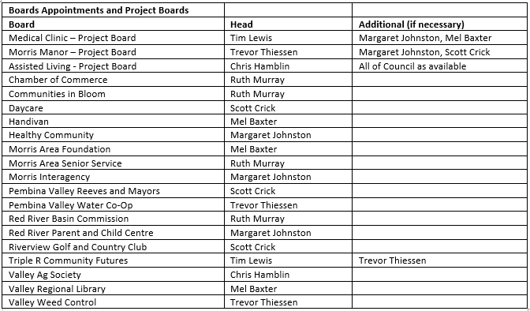

**(Carried)**

**15/11/18 Moved by Councillor Mel Baxter**

Deputy **Seconded by Councillor Ruth Murray**

Mayor Appoint. **BE IT RESOLVED** that Chris Hamblin be Appointed the Depouty mayor for the Town of Morris for a 2 Year term.

**(Carried)**

**MORRIS MULTIPLEX NEW BUSINESS:** None

**BY-LAWS & POLICIES:** None

**UNFINISHED BUSINESS:** None

**NOTICE OF MOTION:** None

**COMMITTEE REPORTS:**

**IN CAMERA ITEMS:**  Personnel Item

Adjournment: There being no further business the meeting was adjourned at 8:49 p.m.

**TOWN OF MORRIS**

**_____________________________________**

**MAYOR**

**____________________________________**

**CHIEF ADMINISTRATIVE OFFICE**